**A**

**The First Term Test**

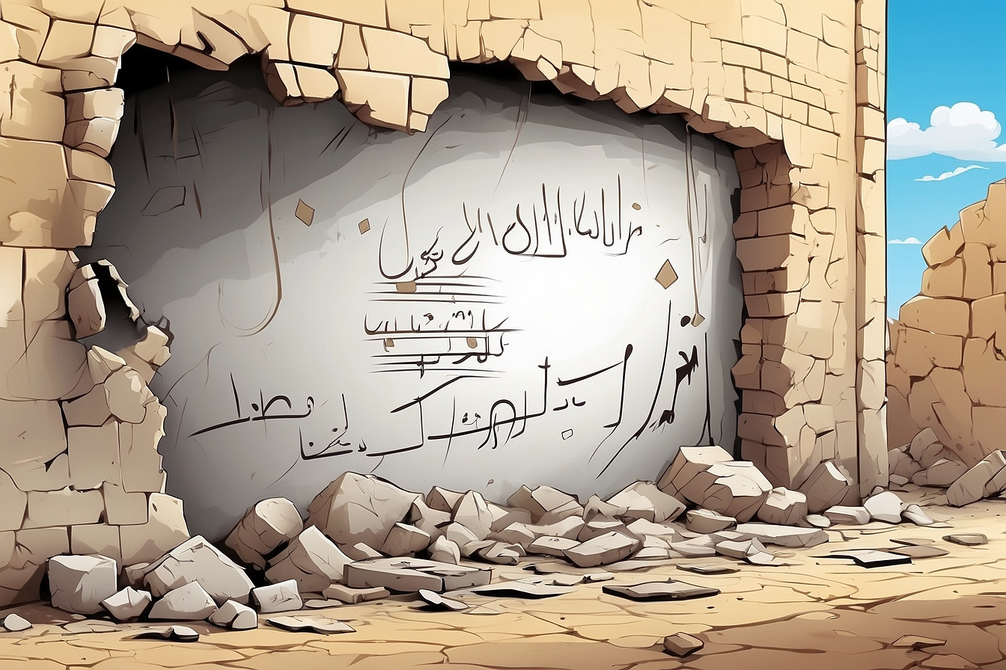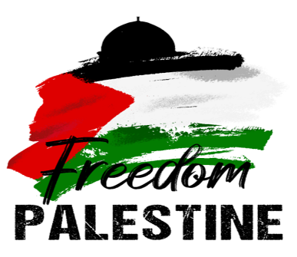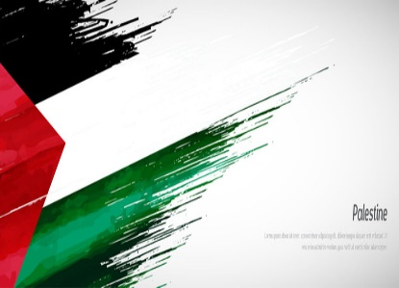

**Full Name :……………….**

**Class :4MS……………….**



Dghin Boudghan Benali known as ‘ Elaakid Lotfi ’ is one of the greatest names in the history of Algeria with the French Colonization.

He was born on May 7th,1934 in Tlemcen. He lived in a well-off family with his parents, his brother and sisters. He studied in a French school. Then, he attended the ‘Madersa of Tlemcen’. Before he finished his studies, he joined the National Liberation Army on October 27th,1955 to bring freedom to his dear country. Lotfi was fond of reading. He always had some books with him and often asked his soldiers to read.

After getting colonel in 1958, he had to settle in Morocco to manage the revolution well. But on March 1960, he came back to Algeria. While he was crossing the borders at Bechar with four militants, the French killed them all. Colonel Lotfi and his friends were very brave and led a big battle to death.

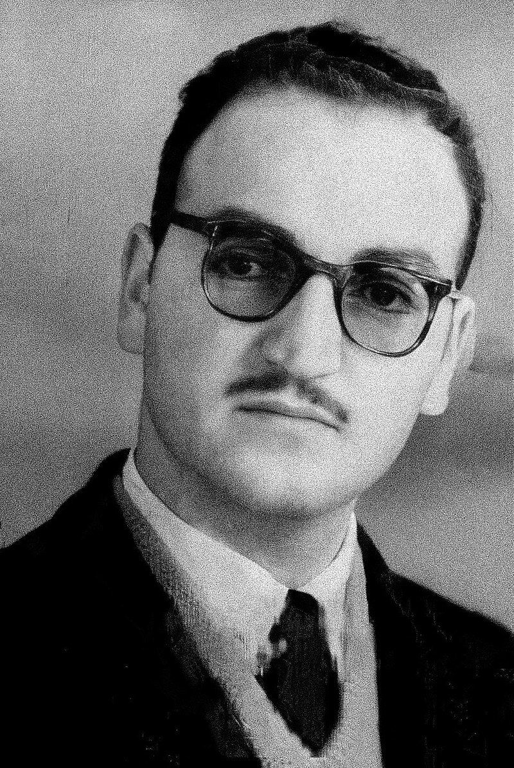

**Part one**

A/Reading Comprehension

Activity 01: Read the text and answer the questions (02pts)

1. Did Lotfi grow up in a poor family?

…………………………………………………………………………………………………

1. When did Lotfi get colonel ?

…………………………………………………………………………………………………

Activity 02: Read the text again and fill in the table. (03pts)

|  |  |  |  |  |  |
| --- | --- | --- | --- | --- | --- |
| Real name | Nickname | Date of birth | Place of birth | Date of death | Place of death |
|  |  |  |  |  |  |

Activity 03: Find in the text : (02pts)

Synonyms to:

Occupation = …………………….. (§1) Returned = …………………… (§ 3)

Opposites to:

Never ≠……………………….. (§2) Birth ≠ ………………………. (§3)

B/Mastery of Language

Activity 01: Finish the following table: (03pts)

|  |  |
| --- | --- |
| Adjectives | Comparative of superiority |
| - Beautiful  - ………………………………  - Happy | - ………………………….  - Hotter than  - ......................................... |

Activity 02: Fill in the gaps with the appropriate connector (cause/result): (02pts)

1. Laarbi Ben Mhidi was killed ………………………………..he refused to surrender.
2. Mark wanted to see the Eiffel Tower, ……………………………..he travelled to Paris.

Activity 03: Circle the silent letter in the following words: (02pts)

Often - Lamb - Half - Write

**Part two**

Situation of Integration: (06pts)

***Moufdi Zakaria is one of the greatest Algerian figures in literature.***

Your teacher asked to write a short biography about this outstanding figure to post it on your school blog. Use the information bellow to help you.

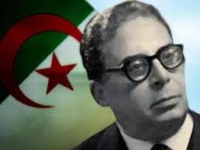 **Full name**: Cheikh Zakaria Ben Slimane

**Nickname:** A school friend gave him the nickname Moufdi

**Date and place of birth:** 1908 – Bni Yezguen – Ghardaia - Algeria

**Occupation:** activist, poet, writer

**Life events:** - (to join) the Algerian revolution – 1955

- (to imprison) by the French for his politics – 1955

**Works:** (to write) ‘Kassaman’, the Algerian anthem / two famous

groups of poetry: ‘Allahab Al Mouquaddas’ + ‘Ilyadat Eljazair’

**Date and place of death:** 1977 – Tunis - Tunisia

………………………………………………………………………………………………………………………………………………………………………………………………………………………………………………………………………………………………………………………………………………………………………………………………………………………………………………………………………………………………………………………………………………………………………………………………………………………………………………………………………………………………………………………………………………………………………………………………………………………………………………………………………………………………………………………………………………………………………………………………